CSE 332 Lab 3 – Advanced Visualization

**Bivariate Scatterplot-**

This is a great explorative tool. We are able to dynamically change our y and x variables. Therefore we can explore our data. As humans, we can understand a lot from a visualization from this, such as correlation, variability, and other patterns. This visualization was tricky to do in d3 as we need to reload data and redraw when we select a new variable from the drop box. We do this by calling the appropriate functions once we select a new value from the dropdown box.

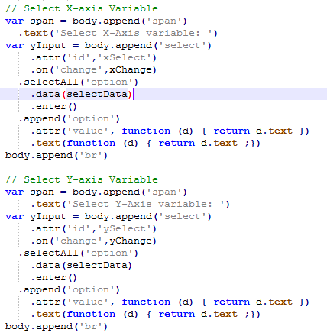

**Correlation Matrix-**

This tool is great to see which attributes share the greatest correlations. Our visualization allows us to quickly identify these attributes, which will give us greater insight for further visualizations.

**Scatterplot matrix –**

Since this visualization already has the 5 strongest attributes, this is a great display. It allows us visually to see all of our data at a glance, and to further understand how and why these attributes are correlated.

**10 axis PCD –**

This visualization serves as a platform for us to see the different patterns in the data. We can pick out certain sections of our data and see how data points are similar to each other in their patterns. However, this display can be a bit messy and difficult to pick out individual data points.

**PCA Plot and Scree –**

This allows us to see how much of our variability can be explained with certain attributes. We see that 6 attributes explain almost 90% of our variability. However this visualization doesn’t show much more than this.

**10 Axis Biplot –**

This plot builds on our PCA analysis of the data and projects the points onto our two strongest attributes. We can see the strength of these attributes from the 10 axis biplot, with longer lines indicating stronger attributes. Projected onto our scatterplot, we can see how our data fits on our axes. Unfortunately I was unable to overlay the star plot onto the scatterplot, however I have included an image from my output, and below it is the scatterplot.

**MDS Displays –**

Unfortunately, I wasn’t able to get the data in the correct format for this visualization as my MDS analysis returned non-2D arrays. This visualization should allow us in theory to replicate a big portion of our data from a very small matrix. Our original data was over 3,000 attributes in length, and our MDS Display would only need 18 data points to display most of this data through our dissimilarity matrices.

Code Snippet: 